MARYLAND ENVIROMENTAL SERVICE  Telephone: (410)729-8200  Website: www.menv.com  MES was established by the General Assembly in 1970. MES operates a unique recycling program for mid-shore residents in Caroline, Kent, Queen Anne's and Talbot Counties.  The MES provides igloo recycling drop-off stations in Caroline County at the following locations:  Choptank: Choptank Marina  Denton: Denton Plaza (formerly Rose’s)  Federalsburg: IGA Parking Lot  Goldsboro: Henderson Road  Greensboro: Holly Road Recycling Ctr.  Preston: Back Landing Road  Recycling Drop-off stations accept mixed paper (now including cereal boxes), #1 & #2 plastic bottles & jugs (no caps) metal cans, and clear, brown & green glass bottles.  The MES also provides regular opportunities to recycle electronics and household hazardous waste. There is a computer recycling drop-off at the Holly Road Site. Further information can be obtained by contacting MES. | CAROLINE COUNTY  DEPARTMENT OF PUBLIC WORKS  County Roads  The Roads Division provides a public road and bridge system for Caroline County’s 481 miles of roadway (403 miles of paved roads, and 78 miles of gravel and dirt roads). Call Caroline County Public Works at (410)479-0520 for more information on the Roads Division.  Mosquito Control  The Mosquito Control program serves an average of 400 private residents in addition to eight towns and eight public parks. There is a fee per spray season. For an application/information, call Jeff Garrett at Caroline County Public Works  at (410)479-4154.  Weed Control  The Weed Control program works in cooperation with the Maryland Department of Agriculture to monitor fields for infestation of noxious weeds. Call Caroline County Public Works at (410)479-4154 for more information. | Caroline County Solid Waste Program  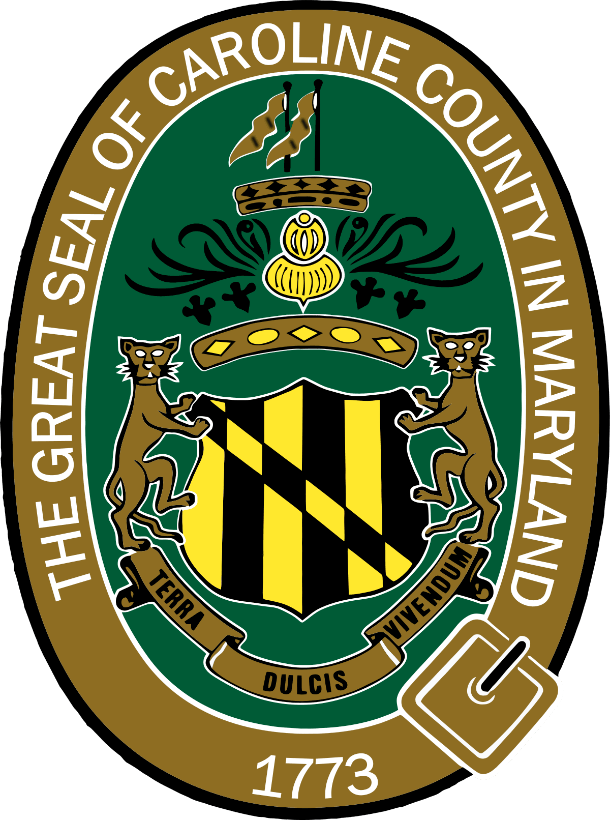  Department of Public Works  520 Wilmuth Street  Denton, Maryland 21629  Tel: (410)479-0520  Fax: (410)479-0409  Hours of Operation:  Monday - Friday  - 7:00 AM to 3:30 PM
County permits can be obtained by contacting:  Department of Public Works  520 Wilmuth Street  Denton, Maryland 21629  Tel: (410)479-0520  Hours of Operation:  Monday – Friday  7:00 AM to 3:30 PM  COLLECTION SITE PERMITS  A permit is required to use Caroline County collection sites: Melville, Old Denton, and Preston. Beginning January 1st. permits will cost $100 for a 12-month period. From April through October, the cost will be prorated on a quarterly basis. A 2nd permit, with the same address as the 1st one, can be purchased for $25. Each vehicle is required to have a separate permit. The permit will be valid from January 1st to December 31st. Proof of County residency is required to obtain a permit. Permit must be affixed to the interior of the vehicle’s windshield on the lower left corner of the driver’s side.  Your permit may not be transferred to any other vehicle or individual. A replacement permit may be obtained free of charge under the following limited circumstances if the Department is provided with the indicated documentation:  Sale of vehicle, if provided with all or a portion of the removed original sticker and proof of sale; theft of vehicle, if provided with a valid police report; loss of vehicle due to accident, if provided with a valid accident report; or broken or replaced windshield, if provided with a copy of the receipt for the repair.  The county run collection sites will NOT accept furniture, white goods, or tires. | COUNTY COLLECTION SITES:  Melville Collection Site  16643 Melville Road  Henderson, Maryland 21640  Hours of Operation:  Wednesday: 10:00 AM to 6:00 PM  Saturday: 8:00 AM to 4:00 PM  Accepts: general household trash up to 10 bags  Recycling accepted: cardboard, scrap metal, and waste oil  —————————————  Old Denton Collection Site  4230 Old Denton Road  Federalsburg, Maryland 21632  Hours of Operation:  Wednesday: 10:00 AM to 6:00 PM  Saturday: 8:00 AM to 4:00 PM  Accepts: general household trash up to 10 bags  Recycling accepted: cardboard, scrap metal, and waste oil  —————————————  Preston Collection Site  105 Back Landing Road  Preston, Maryland 21655  Hours of Operation:  Tuesday: 10:00 AM to 6:00 PM  Saturday: 8:00 AM to 4:00 PM  Accepts: general household trash up to 10 bags  Recycling accepted: cardboard, scrap metal, and waste oil  As of (7/1/25) | Holly Road Collection Site  Mid-Shore II Regional Landfill  Homeowner Drop Off  Operated by MD Environmental Service  11930 Holly Road  Ridgely, Maryland 21660  (410)634-9304  The Regional Landfill Homeowner Drop-Off can be used by area residents. No permit is required.  Hours of operation:  Accepts: Bagged household trash Only  (up to 7 bags)  Recycling accepted: cardboard, scrap metal, waste oil, newspapers, white paper, magazines, #1 & #2 plastic bottles and jugs (no caps), clear, brown, and green glass, steel and aluminum cans, and electronics  NO TV’S  ________________________________________  Mid-Shore II Regional Landfill  12236 River Road  Ridgely, Maryland 21660  (410)634-9304  Hours of Operation:  Monday - Friday 7:00 AM to 3:15 PM Saturday - 7:00 AM to 12:15 PM  Accepts*: furniture, appliances, scrap tires, soil, and landscaping/yard waste material & brush (plastic bags must be emptied), construction debris.  You must use the scale and will be charged a fee  Residential & Commercial Waste Rate is $71.50 Per ton, with a $10.00 minimum up to 260lbs  Yard Brush Rate is $46.50 Per ton, with a $10.00 minimum up to 420lbs  Limit of 5 tires per year, per resident without a Tire Haulers License,  call for cost
  Mon | Tues | Wed | Thurs | Fri | Sat
  7-4 | 10-6 | 10-6 | 7-4 | 10-6 | 7-4

